MLA0105 - Artificial Intelligence and Expert Systems for Gaming
Exp-41: Can a bird fly
Code:
bird(sparrow).
bird(penguin).
bird(eagle).
can_fly(sparrow).
can_fly(eagle)
flies(Bird) :- can_fly(Bird).
flies(Bird) :- bird(Bird), \+ can_fly(Bird), write('This bird cannot fly.').
Output:
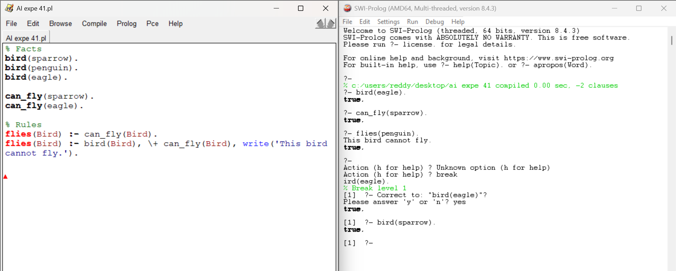
Exp-42: People, DOB, Age Queries
Code:
dob(john, 1990, 5, 12).
dob(ravi, 1985, 9, 22).
dob(anjali, 2002, 11, 3).
dob(kiran, 1995, 3, 19).
dob(sita, 1988, 7, 7).
age(Name, Age) :-
dob(Name, Y, _, _),
Age is 2025 - Y.
get_dob(Name, Y, M, D) :- dob(Name, Y, M, D).
older_than(AgeLimit, Name) :-
age(Name, Age),
Age > AgeLimit.
youngest(Name) :-
dob(Name, Y,_,_),
\+ (dob(_, Y2,_,_), Y2 > Y).
older(Person1, Person2) :-
age(Person1, A1),
age(Person2, A2),
A1 > A2.
Output:
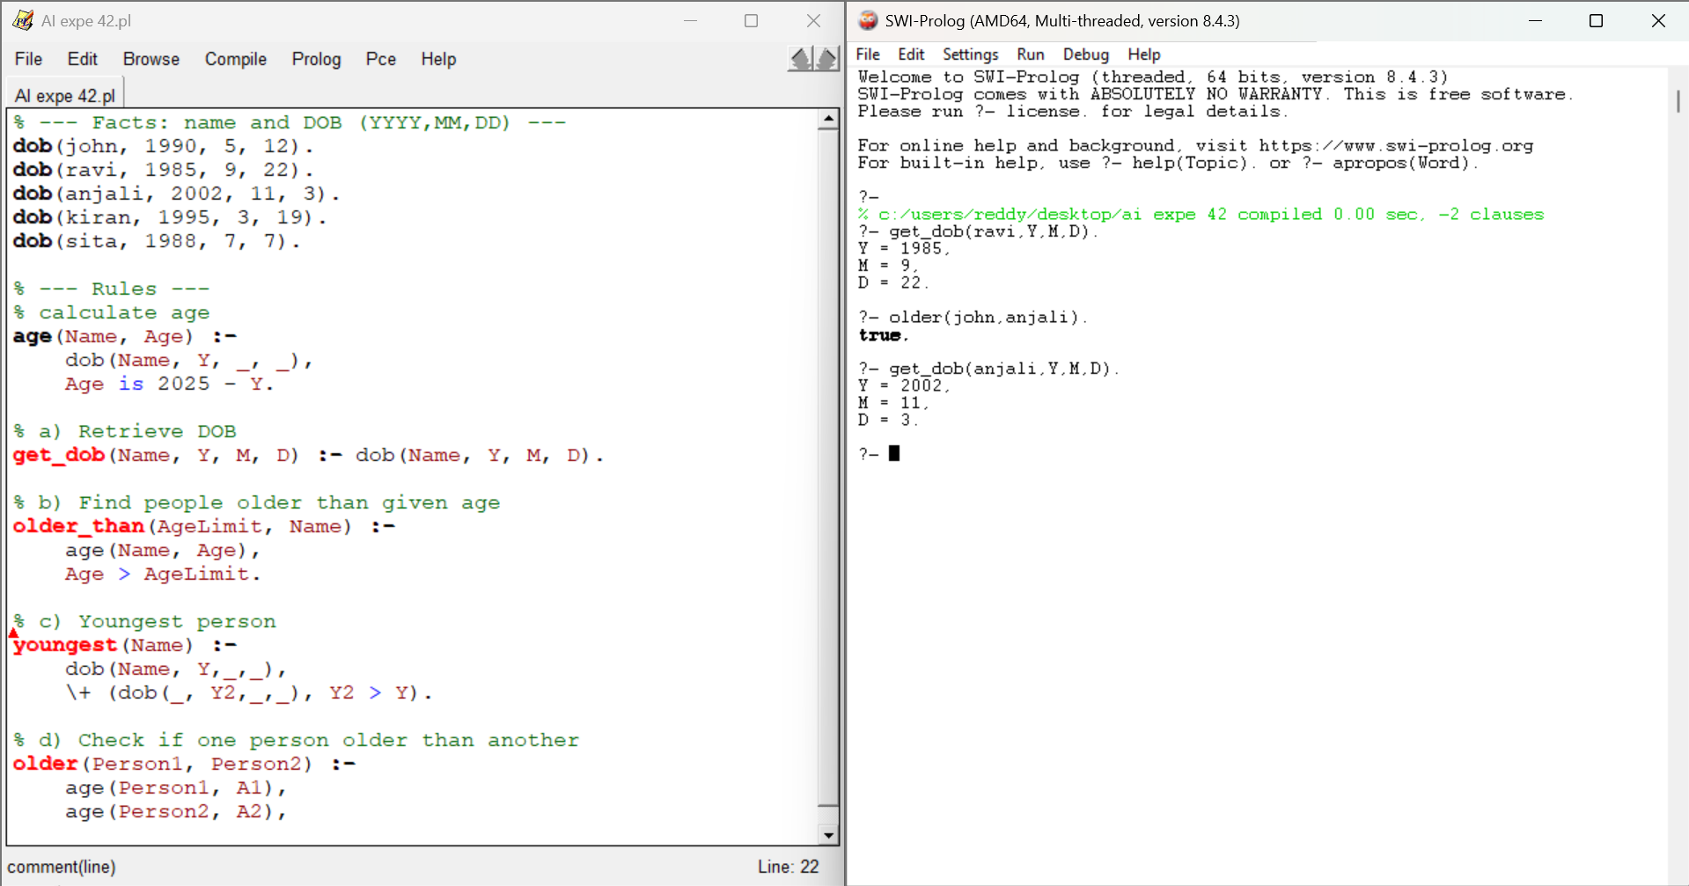
Exp-43: Backward Chaining: Mammal or Bird
Code:
animal(tiger).
animal(elephant).
animal(eagle).
animal(sparrow).
animal(penguin).
mammal(tiger).
mammal(elephant).
bird(eagle).
bird(sparrow).
bird(penguin).
is_mammal(X) :- mammal(X).
is_bird(X) :- bird(X).
Output:
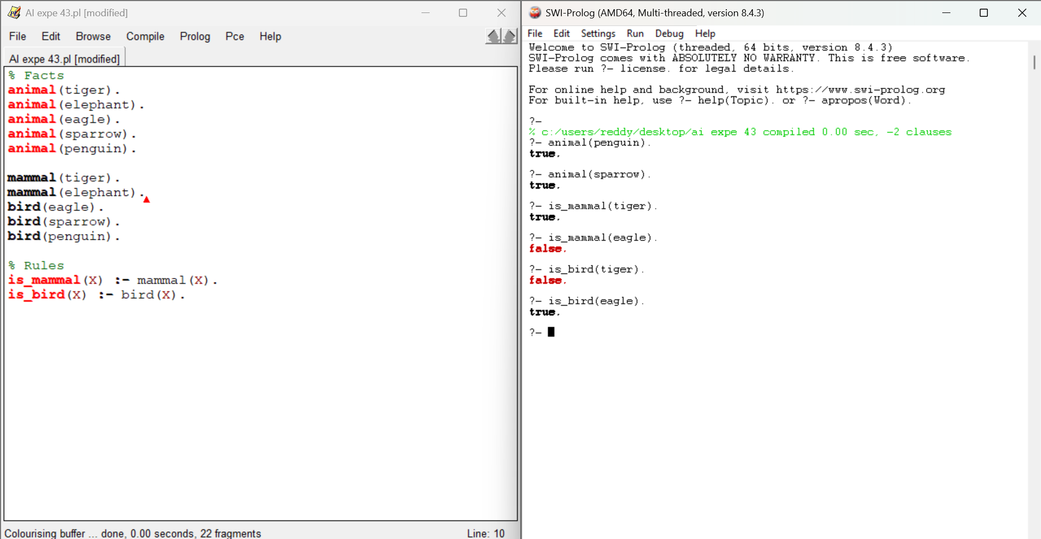
Exp-44: Diet Recommendation Based on Disease
Code:
disease(diabetes).
disease(hypertension).
disease(obesity).
diet(diabetes, 'Avoid sugar, take whole grains, leafy vegetables.').
diet(hypertension, 'Low salt diet, avoid fried foods, eat bananas.').
diet(obesity, 'Low-calorie diet, avoid junk food, eat more fruits.').
suggest_diet(Disease, Diet) :-
diet(Disease, Diet).

Output:
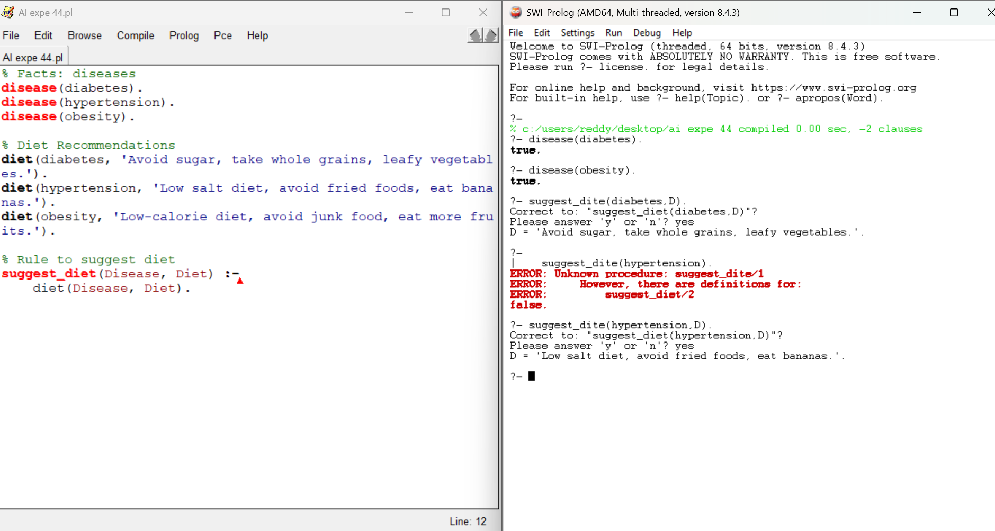
Exp-45: Fruits and Colours (Backtracking)
Code:
fruit_color(apple, red).
fruit_color(banana, yellow).
fruit_color(orange, orange).
fruit_color(grapes, green).
fruit_color(blueberry, blue).
fruit_color(watermelon, green).
fruit_color(papaya, orange).
fruit_color(cherry, red).
% Rule to get fruit and color
get_fruit_color(Fruit, Color) :- fruit_color(Fruit, Color).

Output:
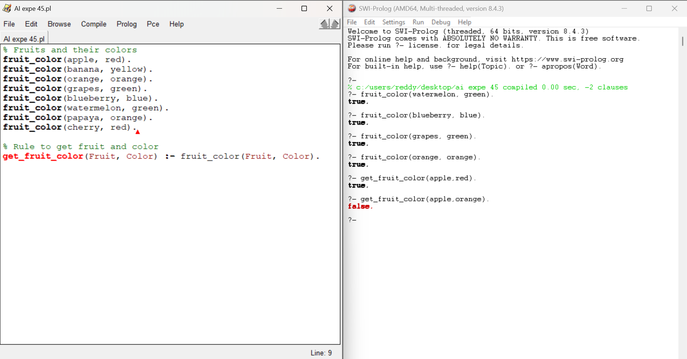
Exp-46: Exam question generator (students, teachers, subjects, codes)
Code:
student(alex, 101).
student(maya, 102).
student(raj, 103).
student(sneha, 104).
teacher(dr_singh, cs101).
teacher(ms_khan, ma101).
teacher(prof_rao, ph101).
subject(cs101, 'Computer Science I').
subject(ma101, 'Calculus I').
subject(ph101, 'Physics I').
make_question(1) :-
student(Name, Roll),
format('Fill in the blank: The student with roll number ~w is _______.~n', [Roll]),
format('Answer: ~w~n~n', [Name]),
fail.
make_question(1).
make_question(2) :-
teacher(TName, Code),
subject(Code, Subj),
format('Fill in the blank: The teacher of ~w (code: ~w) is _______.~n', [Subj, Code]),
format('Answer: ~w~n~n', [TName]),
fail.
make_question(2).
make_question(3) :-
subject(Code, Name),
format('Fill in the blank: The subject with code ~w is _______.~n', [Code]),
format('Answer: ~w~n~n', [Name]),
fail.
make_question(3).
generate_all_questions :-
format('--- Question set (students) ---~n', []),
make_question(1),
format('--- Question set (teachers & subjects) ---~n', []),
make_question(2),
format('--- Question set (codes -> name) ---~n', []),
make_question(3).
Output:
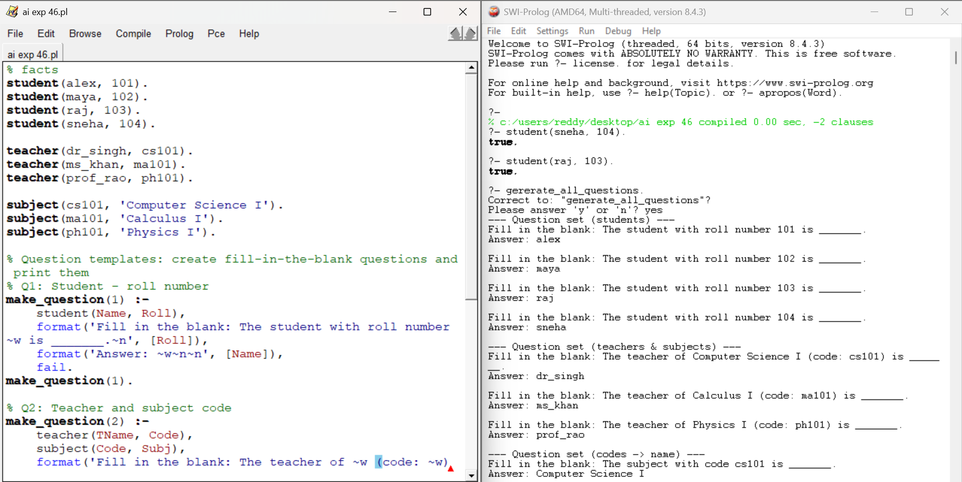

Exp-47:- Forward chaining scenario
Code:
male(john).
male(amit).
female(sara).
female(kavya).
has_child(john, neha).
has_child(amit, rishi).
has_child(kavya, arun).
is_parent(Person) :-
( male(Person) ; female(Person) ),
has_child(Person, _).
is_father(Person) :- male(Person), has_child(Person, _).
is_mother(Person) :- female(Person), has_child(Person, _).
Output:
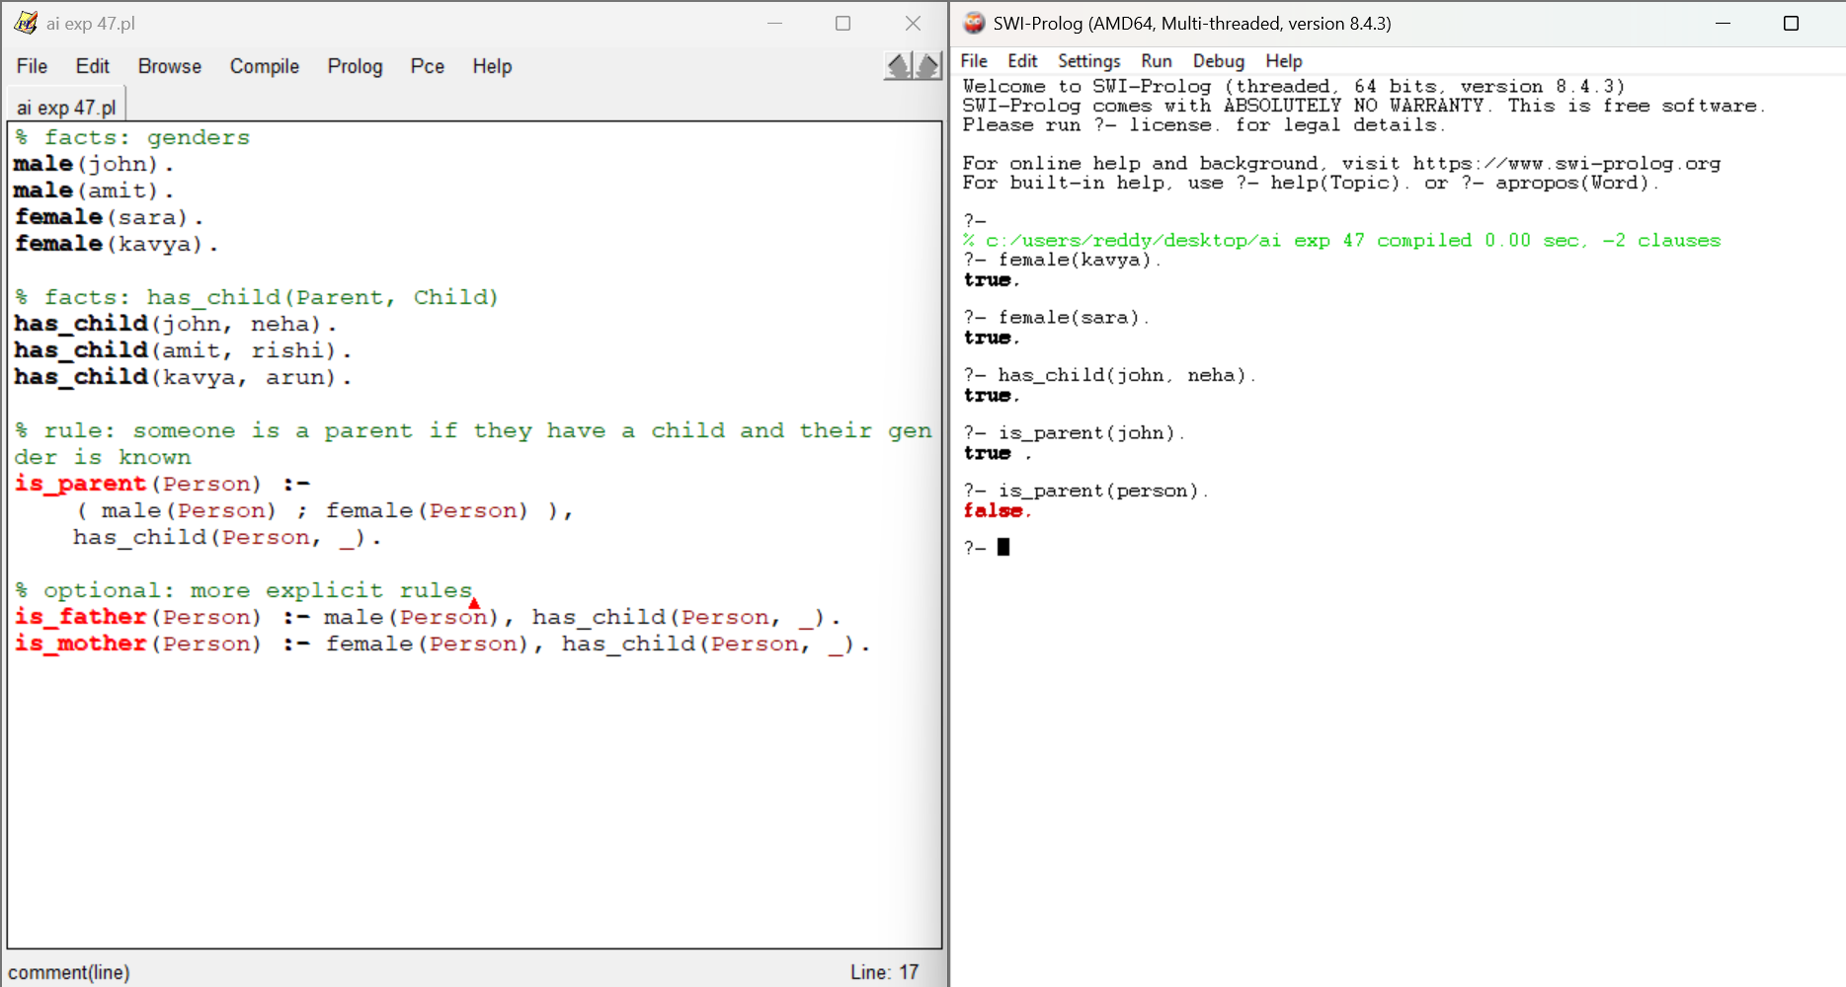
Exp-48: PLANETS database
Code:
planet(mercury).
planet(venus).
planet(earth).
planet(mars).
planet(jupiter).
planet(saturn).
planet(uranus).
planet(neptune).
position(mercury, 1).
distance_from_sun(mercury, 0.39).
mass_in_earth_masses(mercury, 0.055).
position(saturn, 6).
orbital_period_days(saturn, 10759).
day_length_hours(saturn, 10.7).
position(venus, 2).
position(earth, 3).
position(mars, 4).
position(jupiter, 5).
position(uranus, 7).
position(neptune, 8).
distance_between(P1, P2, Dist) :-
position(P1, Pos1),
position(P2, Pos2),
( Pos1 >= Pos2 -> Dist is Pos1 - Pos2 ; Dist is Pos2 - Pos1 ).
closer_to_sun_than_earth(P) :-
position(P, PosP),
position(earth, PosE),
PosP < PosE.

Output:
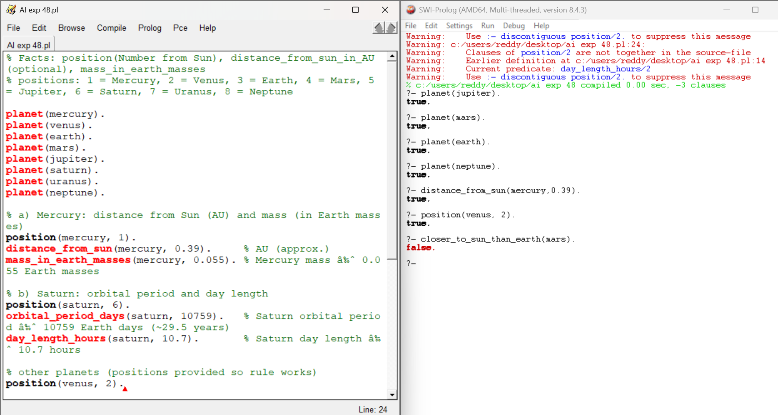
Exp-49: Symptom-based diagnosis with a simple interactive interface
Code:
known_symptom(fever).
known_symptom(cough).
known_symptom(sore_throat).
known_symptom(runny_nose).
known_symptom(headache).
known_symptom(body_pain).
known_symptom(shortness_of_breath).
known_symptom(fatigue).
known_symptom(loss_of_smell).
disease(flu) :-
have(fever),
have(cough),
have(body_pain).
disease(common_cold) :-
have(runny_nose),
have(sore_throat).
disease(covid19) :-
have(fever),
have(cough),
have(loss_of_smell).
disease(migraine) :-
have(headache),
have(nausea) .
diagnose(Diseases) :
findall(D, disease(D), DiseasesUnsorted),
list_to_set(DiseasesUnsorted, Diseases).
ask_symptoms :-
format('Enter symptoms one by one. When finished type done.~n', []),
retractall(have(_)),
ask_loop.
ask_loop :-
write('Symptom: '),
read(Input),
( Input == done ->
write('Finished entering symptoms.'), nl;
( known_symptom(Input) -> assertz(have(Input))
; format('Warning: "~w" is not in known_symptom list, but I will record it.~n', [Input]), assertz(have(Input))
),
ask_loop
).
run_diagnosis :-
ask_symptoms,
diagnose(Ds),
( Ds = [] -> write('No matching disease found based on given symptoms.'), nl
; format('Possible diagnoses: ~w~n', [Ds])
).
show_symptoms :-
findall(S, have(S), L),
format('Current symptoms: ~w~n', [L]).
Output:
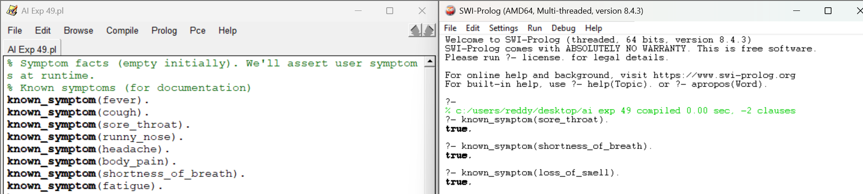
Exp-50: Family Tree Prolog Program
Code:
father(john, lisa).
mother(mary, lisa).
mother(mary, mike).
sister(lisa, mike).
father(tom, mary).
father(mike, emma).
mother(emma, olivia).
parent(X, Y) :- father(X, Y).
parent(X, Y) :- mother(X, Y).
grandparent(X, Y) :-
parent(X, Z),
parent(Z, Y).
grandfather(X, Y) :-
father(X, Z),
parent(Z, Y).
grandmother(X, Y) :-
mother(X, Z),
parent(Z, Y).
sibling(X, Y) :-
parent(P, X),
parent(P, Y),
X \= Y.
sister_of(X, Y) :-
sister(X, Y).
Output:
